**Defuse the Bomb**

**A CSC 102 Project**

**Team: Adam Dom Aidan**

**BOMB DEFUSAL**

**MANUAL**

**The Game**

This project is based on the game Keep Talking and Nobody Explodes1, a cooperative bomb defusing party game. As the game designers put it, “You’re alone in a room with a bomb. Your friends, the 'Experts', have the manual needed to defuse it. But there’s a catch: the Experts can’t see the bomb, so everyone will need to talk it out – fast! Put your puzzle-solving and communication skills to the test as you and your friends race to defuse bombs quickly before time runs out!”

Their version is a software game. Our version takes the idea and realizes it as a physical device with buttons, switches, and more! Although our version can be played just like theirs, players can interact with both the bomb and this document at the same time (i.e., players can both defuse the bomb and serve as the “Experts”, using this document to help disarm the phases).

The backend of our version of the game is a Raspberry Pi2 computer that combines a typical computer with the ability to interact with the outside world through sensors. The underlying software is written in Python3 and is the result of a final group-based project in CSC 102 (The Science of Computing II) in the Computer Science Program at the University of Tampa

**Defusing Bombs**

The bomb will “explode” when its countdown reaches 0:00 or when too many strikes have occurred. You defuse the bomb by disarming all of its “phases” before the countdown expires.

1 <https://keeptalkinggame.com/>

2 <https://www.raspberrypi.com/>

3 <https://www.python.org/>

**Phases**

The bomb has four phases, each of which must be disarmed to defuse the bomb. The phases can be disarmed in any order. Once a phase is disarmed, it becomes inactive and changing it doesn't affect the bomb. Instructions for disarming the phases are provided in this document.

**Strikes**

A mistake in disarming a phase results in a strike. Get too many strikes, and the bomb “explodes”. Sometimes, the remaining countdown time will be decreased and/or go by faster when a certain number of strikes has occurred.

**Information**

A different version of the bomb is randomly presented each time it is“booted”. There are 6,720 unique versions of the bomb with a whopping 1,176,000 possible variations! Disarming some phases will require specific information about the bomb. Pay close attention to the “bootup” text on the bomb's screen.

**Regarding the Toggles**

Only one toggle will need to be switched to complete this phase. There will be a trivia question and the correct answer is the switch that needs to be flipped. If you get the question wrong a strike will be added and a new question will appear. Starting from left to right the toggles are correlated in alphabetical order shown below:

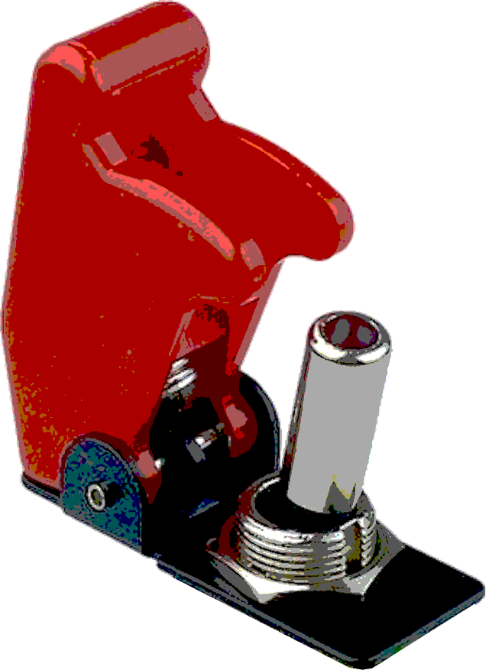





**Regarding the Button**

Eventually, the button will need to be pressed and released to disarm the bomb. However, if you release it at the wrong time a strike will be added. The button can either be blue, red, or green. To release the button at the right time follow the instructions below:

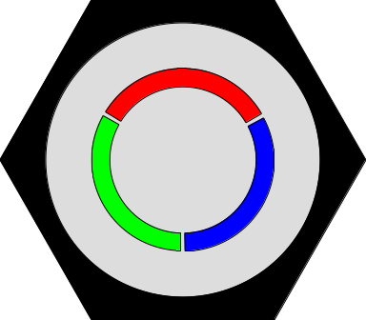

| **Button color** | **Instructions** |
| --- | --- |
| Blue | Release the button whenever |
| Red | Release the button whenever a **5** appears anywhere in the countdown timer |
| Green | Release the button whenever a **0** appears anywhere in the countdown timer |

**Regarding the Wire**

The wries depend on the bomb's serial number, specifically the first numeric digit. Depending on the digit you will have to cut all the wires except one. A strike will be added if you cut the wire that's supposed to stay.

| **First Digit** | **Wire** |
| --- | --- |
| **0** or **1** | Every wire except **B** |
| **2** or **3** | Every wire except **D** |
| **4** or **5** | Every wire except **A** |
| **6** or **7** | Every wire except **C** |
| **8** or **9** | Every wire except **E** |



**Regarding the Keypad**

### 

### Input the code into the keypad using the key which is shown on the screen and below:

### 

### 

### 

### The code you need to enter is the numeric cipher of the word **DISARM.**

### 

### 

### 

### 

### 